CS 161A: Programming and Problem Solving I

# Assignment 7: Coffee Shop

| **Academic Integrity** **You may NOT, under any circumstances, begin a programming assignment by looking for completed code on StackOverflow or Chegg or any such website, which you can claim as your own. Please check out the** [**Student Code of Conduct at PCC.**](https://www.pcc.edu/student-conduct/conduct/quick-view-of-policy/)  The only way to learn to code is to do it yourself. The assignments will be built from examples during the lectures, so ask for clarification during class if something seems confusing. If you start with code from another source and just change the variable names or other content to make it look original, you will receive a zero on the assignment.  I may ask you to explain your assignment verbally. If you cannot satisfactorily explain what your code does, and answer questions about why you wrote it in a particular way, then you should also expect a zero. |
| --- |

## 

Welcome to my online Coffee Shop ordering application!

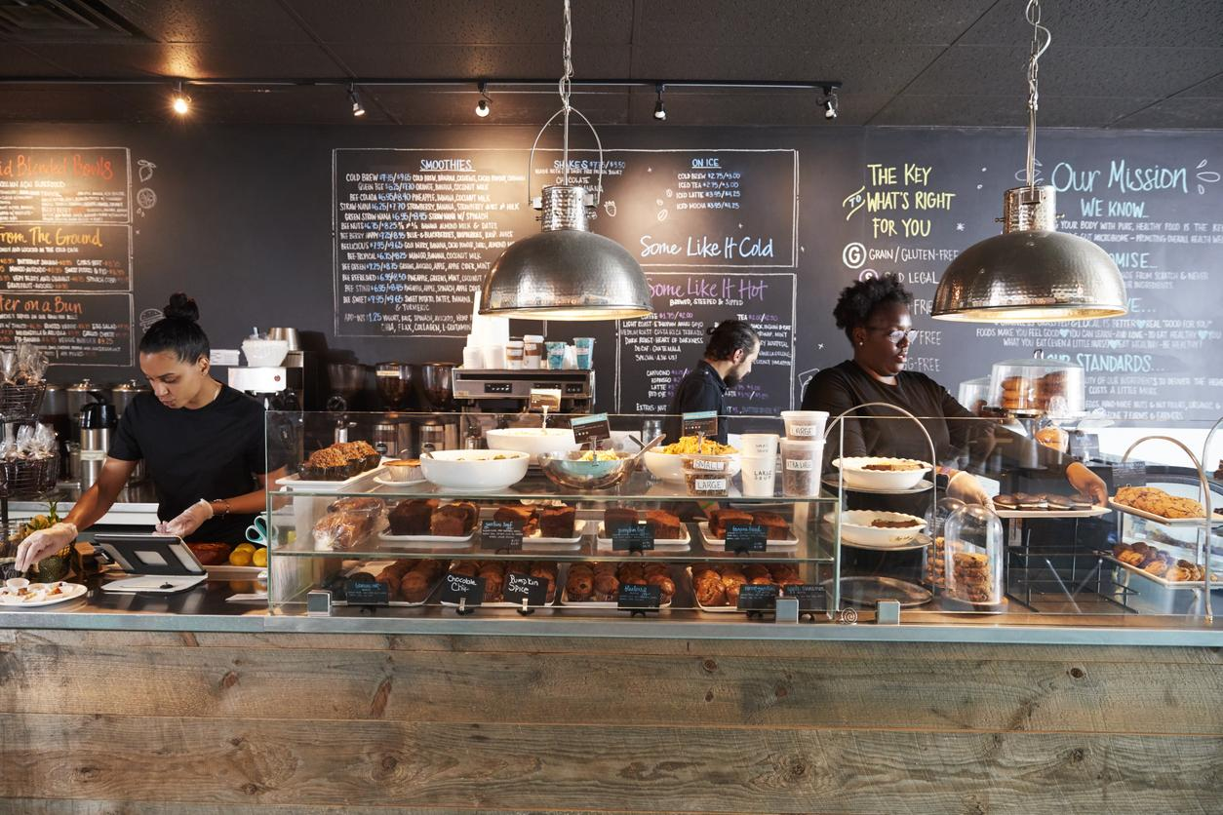

## Purpose

In this assignment you will write an online ordering system for a coffee shop. Your program will continuously print a menu of options for the user to choose from and when they are done it will prompt for a tip amount and print the total pay amount.

After completing this assignment you will be able to:

* Use a while loop to print a menu of items to a user
* Use loops to validate user input
* Use an accumulator variable in a loop to keep track of the amount to pay

## Task

* Open the [Algorithmic Design Document](https://docs.google.com/document/d/1Y0kHPoUWHcbH-_0yma7sMCUR0EvLL7CKEvTGTetqEmU/edit?usp=sharing), make a copy, and follow the steps to create your algorithm.
* You must express your algorithm as **pseudocode** or a **flowchart.**
* Print a welcome message for your program.
* Continually print the menu of options until the user chooses the option to quit.
* Prompt the user for their menu option and validate. If the input is not valid, print an error message and prompt again. Continue to give an error message and prompt until the user enters a valid choice.
* Prompt the user for their sub-choice and validate. If the input is not valid, print an error message and prompt again. Continue to give an error message and prompt until the user enters a valid choice.
* Print the item they chose and the price of the item. Please create constants to hold the cost of each item.
* Add the price of the item to the total price of the order and print the current total.
* When the user chooses the menu option to quit:
  + Display the total price of the item's order.
  + Print tip suggestions for 10%, 15%, and 20%.
  + Prompt the user for a tip amount and validate (should not be negative). If the input is not valid, print an error message and prompt again. Continue to give an error message and prompt until the user enters a valid tip amount.
  + Print the total amount to pay.
  + Format money to 2 decimal places, i.e., print $2.00, not $2.
* Print a goodbye message.

## Criteria for Success

* Test your program using the following sample runs, making sure you get the same output when using the given inputs (in **blue**):

| Welcome to my Coffee Shop!  Please pick an option below:  1. Donuts/Muffins/Pastries  2. Bagels/Toast  3. Coffee/Tea  4. Quit  >> **c**  Invalid Option! Please choose 1-4!  >> **9**  Invalid Option! Please choose 1-4!  >> **1**  Would you like  D: Donuts $4.00  M: Muffins $4.50  P: Pastries $5.50  >> **f**  Invalid Option!  Would you like Donuts(D), Muffins (M), or Pastries (P): **d**  Donuts added.  Total: $4.00  Please pick an option below:  1. Donuts/Muffins/Pastries  2. Bagels/Toast  3. Coffee/Tea  4. Quit  >> **2**  Would you like  B: Bagels $3.75  T: Toast $2.25  >> **b**  Bagels added.  Total: $7.75  Please pick an option below:  1. Donuts/Muffins/Pastries  2. Bagels/Toast  3. Coffee/Tea  4. Quit  >> **3**  Would you like:  C: Coffee $3.50  T: Tea $2.50  >> **t**  Tea added.  Total: $10.25  Please pick an option below:  1. Donuts/Muffins/Pastries  2. Bagels/Toast  3. Coffee/Tea  4. Quit  >> **4**  Your total: $10.25  Would you like to add a tip? Suggested amounts:  10% = $1.03  15% = $1.54  20% = $2.05  Enter tip amount: $ **2.10**  Please pay $12.35  Thank you for stopping by! |
| --- |

* Complete zyBooks section **CS161A 7. Loops Part II** activities.
* Complete all sections of your Algorithmic Design Document.
* Include **pseudocode** or a **flowchart** in part d of the design document.
* Please open and compare your work with the [grading rubric](https://docs.google.com/document/d/1OgJpTGzDOtA6GMqi87ggiLgu79zw71-I80jPjC4eZMQ/edit?usp=sharing) before submitting.
* Remember to follow all [style guidelines](https://docs.google.com/document/d/1avQh7119eRLYZg2ctgeJ57eNRr-KgLr56h2eBxi9_dQ/edit?usp=sharing).
* Download your Algorithmic Design Document as a PDF (File -> Download -> PDF), rename it to a07.pdf, and upload it to the D2L assignment by **Wednesday**.
* Upload your a07.cpp C++ source file to the D2L assignment by **Sunday**.
* Do your own work. Consult the syllabus for more information about academic integrity.

## Additional Support

* Post a question for the instructor in the Ask Questions! area of the Course Lobby.